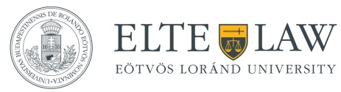

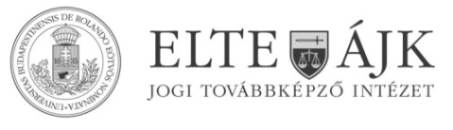

The Institute of Legal Studies
Second Annual Conference in European Union Law

Public Markets in the EU: a Legal Myth or an Economic Reality?

Organised in cooperation by the Hungarian Academy of Sciences, Centre for Social Sciences, Institute of Legal Studies and the ELTE, Faculty of Law

18 November 2016
Council Chamber
ELTE, Faculty of Law
1051, Budapest, Egyetem tér 1-3.

Programme

Chair: Márton Varju (HAS-ILS)
9:00 - 9:25 Arrivals
9:25 - 9:30 Opening
Attila Menyhárd
Dean, ELTE, Faculty of Law
***
9:30 - 10:30 Keynote speech
Professor Martin Trybus
Director of the Institute of European Law, Birmingham Law School, University of Birmingham
Never Finished? The Reform of Public Procurement Regulation in Europe
***
10:30 - 11:00 Coffee break (Pázmány Chamber)
***
11:00 - 12:00 Roundtable discussion
Anita Németh, attorney in law and visiting professor, ELTE, Faculty of Law
Tünde Tátrai, associate professor, Budapest Corvinus University
Attila Dezső, partner, CHSH Budapest
Integrated or National? The Hungarian Public Procurement Market and its Law
***
12:00 Conference ends
***
Organisers: the Institute of Legal Studies, Hungarian Academy of Sciences, Centre for Social Sciences and the ELTE, Faculty of Law.
Registration: konferencia@ajk.elte.hu
Enquiries: varju.marton@tk.mta.hu

